# **Features to be Tested**

## Completed in MVP

* Clear and simple language
* Clean and minimalist design since there will be diagrams etc
* Responsiveness
* List/ show the five (5) stages of the design thinking process: Empathize, Define, Ideate, Prototype, Test
* For the five (5) design thinking stages provide
  + Concise one-line description of what the Define stage accomplishes
  + Brief description explaining the role of the Define stage in the overall process, activities undertaken, techniques used and any deliverables produced.
  + List techniques used
  + Provide an example of a technique/ stage deliverable from successfully completed school project.
* Project examples
* Accessibility features, including image optimisation, image captions and alt tags
* Search Engine Optimization

Optional Features

* Form for Feedback or contact information
* Exercises for users

## A Requirements Testing

Test Date: March 11th 2024

Test Location: Raven Hall 212

Users: TBD

**Test Script**

1. Each user will access the site at <https://dgl409.jchandass.imgd.ca/dtSimplified/> using their personal computer or lab computer
2. The user will navigate to various pages on the site, reviewing various elements
3. The user will complete the following [checklist](https://docs.google.com/forms/d/e/1FAIpQLScc38D7WxTNHL67Aze_GUbYZDy0TlL-yLvE8rnSnWqi3C_i5A/viewform?usp=pp_url&entry.267743031=No&entry.788991593=No&entry.768269897=No&entry.2046275832=No&entry.1758896307=No&entry.556670091=No&entry.1410356361=No&entry.267428497=No&entry.955195984=No&entry.1242679480=No&entry.1618427583=No&entry.1378273234=No&entry.903036005=No&entry.1128699409=No&entry.1963155462=No&entry.1688255653=No&entry.1254722015=No&entry.692195158=No&entry.912616002=No&entry.84382197=No&entry.1818075968=No&entry.960263364=No), including any feedback on the form
4. The developer will collate data and apply feedback to site revision

**Feedback**

All responses will not be shown, instead a summary of feedback is provided. All responses can be accessed [here](https://docs.google.com/spreadsheets/d/1PC_hfKxLGSwToqyYLWMnc2PxFfK4Cp-jFYmJ7Xt4CRA/edit?resourcekey#gid=654894193).

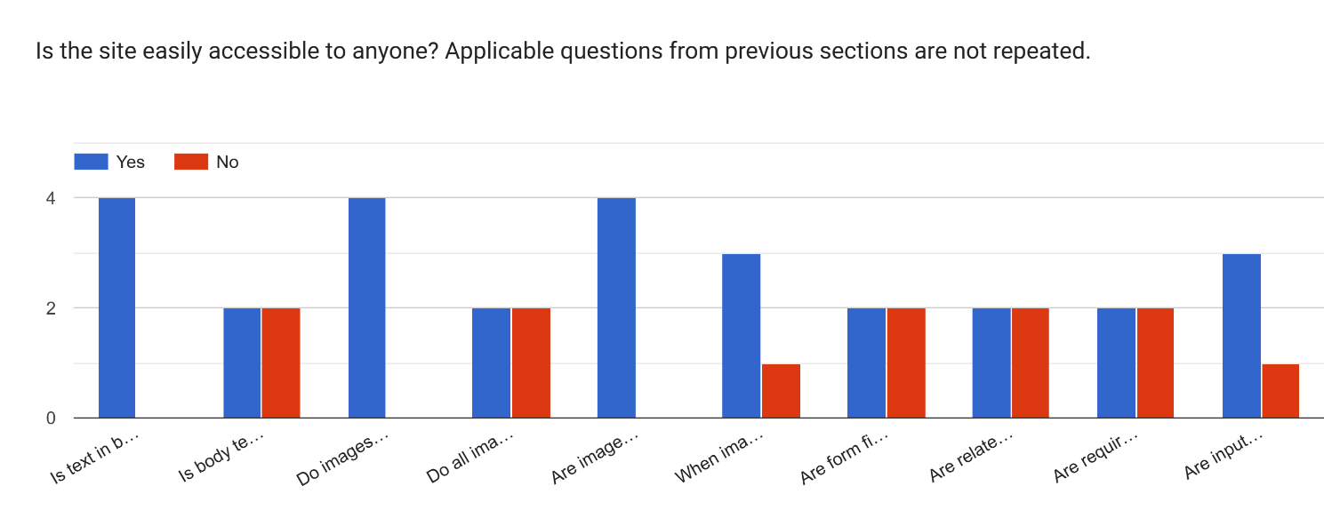

Figure 1 Graph showing summary of responses to questions on site accessibility

## B Performance testing will be carried out by the developer, using this checklist

|  |  |  |  |
| --- | --- | --- | --- |
| **Performance** | | | |
| Test Area | Specific Test | Passed Y/N | Comments |
| Speed Testing   ([Make the Web Faster  |  Google Developers](https://developers.google.com/speed)) | Does page load at 90% or higher? | No  See screenshot below |  |
| Browser Testing | Browser 1 – MS Edge | Yes |  |
|  | Browser 2 – Google Chrome | No | Home screen loaded, hamburger menu appeared, and dropped down when hamburger was clicked but when another page was clicked it did not load |
|  | Browser 3 - Browser | Yes | Font size too small |
| Responsiveness | 320px to 480px | Yes | Home page only in Chrome, other pages did not load so cannot tell |
|  | 481px to 768px | Yes |
|  | 769px to 1024px | Yes |
|  | 1025px to 1200px | Yes |  |

## Usability Testing

Test Date: March 11th 2024

Test Location: Raven Hall 212

Users: TBD

1. Each user will access the site at <https://dgl409.jchandass.imgd.ca/dtSimplified/> using their personal computer or lab computer
2. The user/s will attempt to complete the test scenarios

Test Scenario 1: The user needs to generate ideas to solve the problem of students purchasing less from the cafeteria because of the long time it takes to purchase. The user needs to learn about some ideation techniques.

Test Scenario 2:

The user wants to learn about the stages of design thinking because they are uncertain about the order.

Test Scenario 3:

The user wants to learn how to create low-fidelity wireframes, while using their phone on the bus.

1. The scribe will document the user’s actions, without interference or prompts
2. The developer may ask the user questions about whether they had challenges, possible improvements
3. The developer will collate the data and apply feedback to site revision

**Test Scenario 1**: The user needs to generate ideas to solve the problem of students purchasing less from the cafeteria because of the long time it takes to purchase. The user needs to learn about some ideation techniques.

**Test Scenario 1 User R**

User opened site

Clicked on Ideate on Menu

Figure 2 Expected User Flow Scenario 1

**Test Scenario 2:**

The user wants to learn about the stages of design thinking because they are uncertain about the order.

**Test Scenario 1 User R**

User opened site

User scrolled on homepage, saw stages

Figure 3 Expected User Flow Scenario 2

**Test Scenario 3:**

The user wants to learn how to create low-fidelity wireframes, while using their phone on the bus.

**Test Scenario 3 User A**

User opened site

Clicked on Prototype on Menu

Clicked on Projects

Saw wireframe example

**Test Scenario 3 User R**

User opened site in mobile view

User hesitated was unsure

Clicked on Prototypes

Clicked on Projects

Figure 4 Expected User Flow Scenario 3

**Overall Feedback**

Content

* Content was free of grammatical and spelling errors
* Content was clear and concise with good hierarchy
* Section headings and labels can be more descriptive

Navigation

* Sub-menus or drop-downs can be used so that user can easily see what techniques are under the various stages
* Navigation is sticky but has transparent background, body content is visible behind, place navigation in hero or change background
* Change link colour, contrast is too low

Site accessibility:

* Images don’t have captions
* Body text size, is too small especially on mobile
* Text contrast in the heading needs to be higher
* Form fields need to be clearly labelled and better grouped
* Suggestion was made for form to be on page not open in separate page using separate form tool